Logistic Regression Report

Chosen best Learning Rate: 0.1

Test Accuracy: 63.79% (lr = 0.1)

Learning rate (lr)  [Max_iter = 500] | Validation Accuracy
0.1 | 63.48%  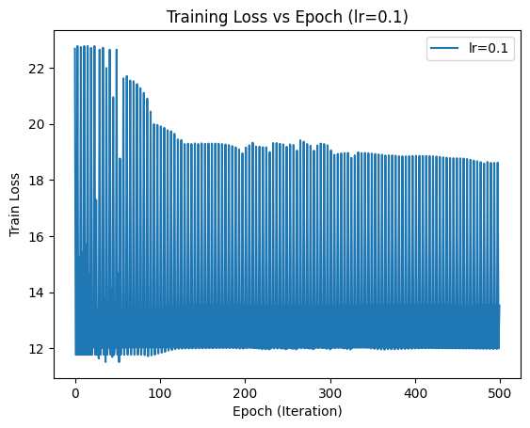
0.01 | 63.48%  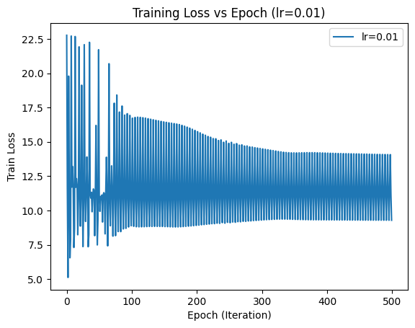
0.001 | 62.61%  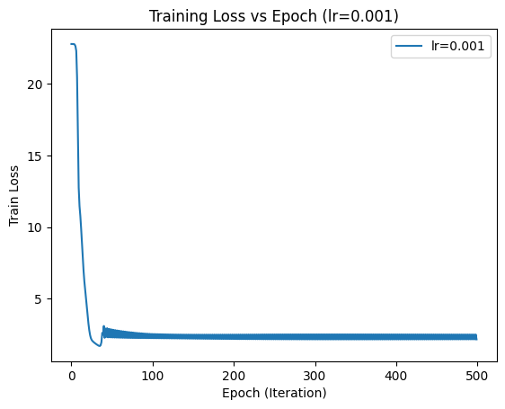
0.0001 | 45.22%  